Prof. Victor Frankenstein (he/him)  Please call me Professor Frankenstein or Prof. F.  Phone Number/Voicemail:  (951) 101-1818 | Email/Messages: Victor.Frankenstein@  GenevaUniversity.edu  You can always email me, but the fastest way to reach me is through the inbox in our class Canvas shell. | Student Hours (no appointment necessary – just stop by):  Mon/Wed 9-10am in office  Tues/Thurs 1-2pm in office  Friday 10-11 in Zoom  (zoom.bitly.url.http.1234)  Office: Quad 300

Welcome!

This course will help you develop your critical reading and academic writing skills, and it will push you to think deeply about complex ideas, wrestle to understand differing perspectives, and communicate your ideas effectively. In other words, this course will help you become a more successful college student and help prepare you for the demands of the workforce after you graduate [Wendy Silva]. These critical reading, writing, research, and communication skills are also the most sought-after skills in most any workplace and refining them will make you far more competitive in the labor market and, if you’re already working, will make you a more desirable employee [Tammy Kearn]. A survey of hiring managers and human resource professionals in an article from Inside Higher Ed indicates that listening skills, attention to detail and effective communication are the most essential skills for employees, but 73% of the employers surveyed reported that finding employees with these skills is “somewhat or very difficult” (Bauer-Wolf). English 1A can help you hone these skills and become one of those employees [Carla Reible]. You will all be writing in a variety of essay styles this semester including research-based. With hard work, my help, and the help of your brilliant classmates, you will write 7500 words you are proud of. I know, for many of us, taking online classes/going to college in a pandemic/returning to school in these uncertain times [etc.] is not ideal. However, if we all do our best to be present, engaged, complete work on time, and ask for help if needed, we can achieve success together [Wendy Silva].
Another key feature of this class is that it is student-centered and community-based, which means that much of the work we do will be done together, through writing activities, discussions, and peer reviews, as opposed to me lecturing. Your voices matter more than mine in this class because you have incredible minds, work ethics, experiences, and knowledge that will help us learn not only reading and writing skills, but necessary critical thinking skills. This course will require a lot of time and effort, and we will have moments of success, pride, confidence, but also challenges, frustrations, and setbacks. All of these are part of the learning process, and we must support one another to overcome whatever challenges we might face. We can do it! [From Wendy Silva] |   Got this you do!      

Course Description
English 1A emphasizes skills in critical reading, and writing, including research. Integrated reading and writing assignments respond to various rhetorical situations. Students will produce a minimum of 7500 words of assessed writing. Classroom instruction integrates writing lab activities. Students may not receive credit for both ENG-1A and ENG-1AH. 72 hours lecture and 18 hours laboratory.

Course Format
Our class meets twice a week on campus / meets once a week for two hours [on campus / in zoom] and has a second asynchronous session in Canvas / is a totally online course with weekly modules of instruction etc. and has a weekly lab component of 50 minutes each week.
[Could explain here if WRC activities are integrated into course calendar or have a separate schedule]
[Any other regular schedule items could go here – if major assignments are always due on a particular week day and time; if WRC assignments are due on a regular day; if there is a typical assignment cycle it would help students to know; see Carla Reible’s sample asynchronous course weekly schedule below.]
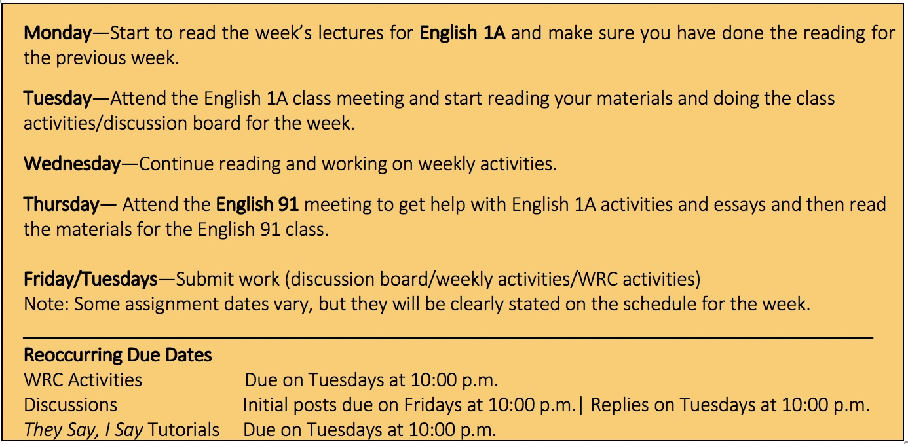

Required Course Materials
<< Add required textbook, software, subscriptions, equipment and/or other resource. >>
- [Course reading material]
- A folder or binder to organize all class documents, worksheets, assignments sheets, etc. (if you plan to print out the materials). If you are not printing your materials, I recommend you make a folder on your computer labeled “ENG 1A” so that you can save all assignments sheets, essays, etc. in that one folder. These organization skills will be required in any professional field, so it is a good idea to start developing these skills now. [Wendy Silva]
- Computer Access & Internet Access: You will need internet and computer access all semester. RCC has laptops for rent, if you need one. I do not recommend using just a cell phone for an entire semester of classes; the feedback on assignments in Canvas won’t be visible on your phone. Please see the student resources section of this syllabus for info on checking out a laptop and, as available, a wifi hotspot [adapted from Wendy Silva]
- Self-enrollment in the Writing and Reading Center for your Weekly Lab Hour

Student Learning Outcomes
Upon successful completion of the course, students should be able to demonstrate the following skills:
- Write texts using diverse rhetorical or multimodal strategies.
  - This is also a general education critical thinking learning outcome: Students will be able to demonstrate higher-order thinking skills about issues, problems, and explanations for which multiple solutions are possible. Students will be able to explore problems and, where possible, solve them. Students will be able to develop, test, and evaluate rival hypotheses. Students will be able to construct sound arguments and evaluate the arguments of others.
- Write an inquiry-driven, analytical, or argument-based research essay on a culturally relevant issue that demonstrates critical reading and analysis of text-based sources.
  - This is also a general education communication skill learning outcome: Students will be able to communicate effectively in diverse situations. They will be able to create, express, and interpret meaning in oral, visual, and written forms. [I cut the second half of the GESLO all about quantitative (math) skills.]

Learning Community Guidelines

Conduct & Classroom Civility
The RCC English and Media Studies department is committed to providing its students with a safe and inclusive environment in which to learn and thrive. It is our mission that you, our students, regardless of your background, feel included in the course conversations, welcomed to freely engage in discussion and dialogue, and represented in the material we expose you to. [Star Taylor] We want to create a classroom that encourages learning, collaboration, and risk-taking, and that fosters the inclusion of multiple voices, respectful engagement, and topical inquiries that examine evidence and learners’ experiences. [Wendy Silva and Audrey Holod] To do this, I ask that each of you exercise acceptance and respect for one another; this means each of us is responsible for helping foster an inclusive and supportive classroom community for people of all ages, sexes, races, national origins, cultures, ethnicities, citizenships, socioeconomic backgrounds, gender identity/expressions, sexual orientations, physical or mental abilities, and religions. Offensive and oppressive language regarding personal identity or experience is extremely damaging to the respectful community we’re trying to build and will not be tolerated. If any behavior is disruptive, disrespectful, or otherwise inappropriate, I will address it immediately. In turn, if I say something that offends you or you feel is damaging to our classroom environment, please let me know. We are all here to learn and to grow, and we all make mistakes, me included [Wendy Silva]. We encourage our students to share their opinions and respond to their peers and to us, in a respectful and constructive manner. It is our hope to provide you with the space and opportunity to not just survive academia but to thrive in it. We welcome you to our classes and invite you into the conversation! [Star Taylor]
Class Responsibilities & Participation
Remember, Teamwork makes the dream work! As cheesy as that sounds, it’s true. In order to be successful, we must learn to work together and support each other in this journey. [Carolyn Rosales, incl. graphic] As a reminder, successful students regularly participate in class. This is a skills-based, critical thinking, reading and writing class, and therefore most of the content of the course depends upon your contributions [Tammy Kearn]. To aid in this pursuit, as members of this community we will:
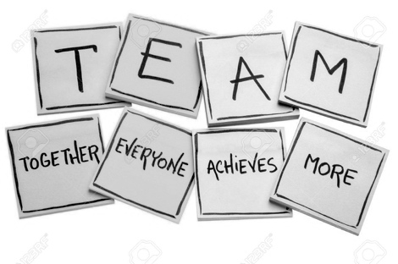
- Come to every class prepared with proper materials, including readings, homework, and our minds.
- Participate actively during group discussion & activities.
- Turn off or silence cell phones and similar devices
- Use laptops & tablets appropriately and only to help facilitate our class work
Other responsibilities we expect of each other in class and in groups:
- _______________________________________________________________________
- _______________________________________________________________________
- _______________________________________________________________________
- __________________________________________________________[Carolyn Rosales]

OUR CLASS -- OUR COMMUNITY

There is a lot of research that shows that students who form communities (friendships, study groups, class networks, cultural organizations) have more resources available to them to help them to succeed. But don't take my word for it, listen to the words from students quoted in the RCC Student Equity report from May 2017:

"When I first started going here, I didn't really know anybody, and I was just having so many problems with class. I felt really, really stupid...like exceptionally stupid because I felt like I was the only person who was having these problems. But then, I made friends, and I realized that I wasn't the only person who was struggling."

"I talked to some intern here who I know. He said that if students get involved with campus activities, it leads to students having positive experiences and that leads to positive behavior, which leads [students] to focus more on their education, which leads them to complete their coursework, which leads to graduation. So, just get involved." ~RP group report [Kelly Douglass]

[Additional language for synchronous Zoom meetings and camera norms]
Our class and community are most effective when it is comfortable for each student to risk asking questions and learn. To create this environment, I am going to ask you to turn on your camera so that other students can see you and learn to trust you. Let’s face it, a black box in a Zoom meeting is hard to talk to! [Carla Reible] I’m also asking you to have your camera on if you can because without that, I just don't know if you are getting what you need from class, from me. Professor C. Thi Nguyen wrote about teaching in Zoom classes in The Chronicle of Higher Education: “I totally get the worries about student privacy and invasiveness,” he wrote. “But I also know that my teaching gets radically worse when I'm facing mostly all black squares.” In short, he explained to his students how he relies on reading their faces so he can tell what is and isn’t being understood. He told them that if fewer than one-third had their cameras off, it didn’t harm his teaching. If half turned cameras off, his teaching got significantly worse. “A bunch of students said that they had ‘never even thought’ about what it felt like from the teacher's POV, to teach to a bunch of no-camera squares,” he wrote. “My hope is that what's going on is: students who have a strong reason to have cameras off, have them off. But that many people have only a mild preference for having their cameras off, which is now being outweighed by some sense of a communal good.” I don’t require cameras to be on, but I am asking that you consider keeping them on in the main room as often as you can, and even moreso in breakout rooms for the good of our learning community. Group work is an opportunity to talk with other students, go over the material, and ask questions, and if you can't do that on camera, the work of class should be done via your mic and the chat. [Kelly Douglass]

Communication Plan
A key principle for our semester together is that we have to communicate. I will do my best to be as clear and direct as possible about assignment expectations and in my feedback on your work [Kelly Douglass]. The writing you do in this class will ask you to question your own assumptions about how things work in the world, and I ask you to be willing to explore ideas that may, on the surface, appear to be obvious, self-evident, or not worthy of exploration. I will always do my best to answer any questions you might have, and I will always be respectful of you, even as I challenge you to work those thought-muscles [James Ducat].
In return, I need to hear from you! I can give feedback, provide support, and connect you to resources, but I often need you to let me know what and when you need more time on an assignment, a question answered, or help finding a resource. The fastest way to message me is via the inbox in Canvas. I have the app downloaded on my phone, so I get alerts whenever you message me. I will respond as soon as I can M-F between 9-6 and at least once a day on the weekend. You can also email me, but I typically check that once a day M-F and don’t check email on the weekends. However, the best way for us to connect is in person. Please stop by during my student hours so we can chat about your work, your questions, our class, your future plans, the best movies, whatever. [Kelly Douglass] This is an entertaining take on how stopping by to chat with your professor might go. [from Tammy Kearn]: https://vimeo.com/270014784

Course Grades

Breakdown
Graded Activities & Assignments | Individual Points | Total Points
Assignment
Assignment
Assignment
Assignment | Note that a substantial portion of the final grade should come from evaluated writing assignments.
Assignment
Assignment
Assignment
Total |  | Total points

Scale
Please consider including in your assignment information full-grade revision opportunities. As of Fall 2021, the word count requirement for 1A is 7500, so there is more room in the course to set aside built-in revision time – this is both student centered and emphasizes the learning outcomes: have students learned to write according to our course outcomes and content goals by the end of the term? Let their grade reflect that.
<< Add grading scale. >>
Percentage | A
Percentage | B
Percentage | C
Percentage | D
Percentage | F  [NOTE: If you have any grade categories beyond essays, exams, or quizzes – items like class participation perhaps – consider a sentence or two in this section elaborating what that category is for student clarity.]

Student Support and Resources

Academic Support Services
Academic Counselors: 222-8440
Admissions & Records: 222-8600 (The website starts with first time students, but there are forms and documents for current students at the bottom, and other resources for all students on the left side menu.)
COVID-19 Resources: Because of the college closure and the many hardships related to the COVID-19 closure of the college, RCC is aware that students may have many needs. The college has created a webpage that pulls together many resources and answers many questions you may have. (And if there’s something you are looking for that isn’t here, let me know, and we will look together!)
Disability Resource Center: 222-8060 If you have a physical, psychiatric/emotional, medical, or learning disability that may impact your ability to carry out assigned course work, please contact the DRC. They will review your concerns and determine, with you, what accommodations are necessary and appropriate. All info and documentation are confidential.
Engagement Centers for your Academic Pathway: You can get individual support and guidance in your instructional pathway by visiting our dedicated engagement centers: CTE (Career and Technical Education), LHSS (Language, Humanities, and Social Sciences), or STEM (Science, Technology, Engineering, and Math).
EOPS (Extended Opportunity Programs and Services)/CARE (Cooperative Agencies Resources for Education)/Next Up: 222-8045
Financial Aid: 222-8710
Laptop / Wifi Hotspot Information: RCC has a limited supply of laptops for students who need them. If you already have access to a computer, we ask that you continue using that computer so that those without access have a chance to borrow a laptop and enroll in RCC online classes, perhaps for their very first time. RCC also has a limited supply of hotspots for students who need them. If you already have easy access to the internet, we ask that you continue using that connection as this will allow less fortunate students a chance to borrow a hotspot and enroll in RCC online classes. Students can now place requests for RCC laptops and/or hotspots through the library’s website and pick them up at scheduled curbside pick-up times.
- Laptop Checkout Link
- Request a Hotspot Link
Library Online: Access digital materials and other resources at the RCC Library.
Name change information: If you would like your chosen name to appear on class rosters, student photo ID, and communications from the District, please email this Chosen Name or Gender Identity Changes form to Admissions and Records (admissionsriverside@rcc.edu)​.
- Your legal name will appear on transcripts, degrees/certificates, or financial aid disbursements. Your original RCCD student email address and Canvas login will not change. Please allow 3-5 business days for your RCCD student email display name to change.
- If you would like a student ID card that reflects a current photo and your chosen name, fill out the following form and provide a picture and a copy of a current photo ID. Your new student ID card will then be mailed to you.
- In your Canvas class shell, you can update your display name and include your pronouns if you'd like! Login to Canvas and go to Account > Profile.​
- How to change your name on zoom: https://nerdschalk.com/how-to-change-your-name-on-zoom-on-pc-and-phone/
- These links and more information are available at RCC’s LGBT Allies home page: https://www2.rcc.edu/lgbt-allies/Pages/Home.aspx

Outreach / Welcome Center: 222-8574

Student Services and Support Programs

Transfer Center: 222-8446

TRIO: 222-8312 or 951-328-3580

Tutoring Resources: [Lani Kreitner] For English 1A, your primary and best tutoring resource is to use our WRC. But, you also have access to eight hours of Smarthinking tutoring, which is available seven days a week, between 5 PM and 9 AM. To access the online tutors, go to https://services.smarthinking.com. Your username is your "student.rccd.edu" email address. Your password is your two-digit birth month, four-digit birth year, and last five digits of your RCC student ID. Example: February 1995 and Student ID 3985602 would be "02199585602." You can change your password in the "Profile" section of the "Manage Account" tab.

Writing and Reading Center: You are required to enroll in the WRC for your English 1A class, but this is a key academic support. You can meet with tutors and instructors to help you with your work in English, but also in your other classes. Ask me or lead instructor Professor Kruizenga-Muro about ILA 800 for additional WRC access and support beyond English 1A.

College and Community Support Services (Non-Academic)

Basic Needs
“We learn as whole people. To learn effectively you must have basic security: a roof over your head, a safe place to sleep, enough food to eat. If you’re having trouble with any of those things, please talk with me or with the Dean of Students. Together we can work to make sure those needs are met.” – Yvonne Seale, SUNY-Geneseo

RCC and the city of Riverside offer several basic needs to help students and community members. Locally, RCC has a food bank and clothing program, offers enrollment for CalFresh, and has access to emergency funds and grants until available. I can help with some of these, and there is also a lot of info here: https://www.rcc.edu/student-support/relief-assistance.html
For a comprehensive list and access to basic needs including shelter, food, and healthcare, you can call 211 for the Riverside County Referral Line.

ASRCC: Please also investigate student clubs and organizations on the webpage of ASRCC (Associated Students of RCC) (and other ASRCC benefits). If you have any questions about any campus clubs or programs, please ask!
CalWorks: 222-8648
DREAMers Program
Engagement Centers:
- Engagement Centers for your Academic Pathway
- Foster Youth/Guardian Scholars: 222-8878
- La Casa: 222-8168
- LGBTQIA and Ally Resources
- Umoja Community: 222-8130
- Veterans Services: 222-8607
Health Services (Including Managing Stress and Mental Health) 222-8151: Many college students have academic commitments, relationships, outside jobs, and family issues and other obligations that at times may overwhelm them. This can be even more difficult during these stressful times. If you feel you need assistance with any of these or other issues, RCC has services that are designed to help you maintain your emotional and physical health. You can learn more about the broad range of confidential student services, including counseling and mental health services available on campus by visiting the Student Health and Psychological services website. Additionally, Riverside County offers a 24-Hour Crisis and Referral Line simply by dialing 211. If needed, the National Suicide Prevention Hotline offers immediate assistance and can be reached at 800-273-TALK.
Student Programs and Clubs

Pandemic Stress Management [from Alex Gilbert:]
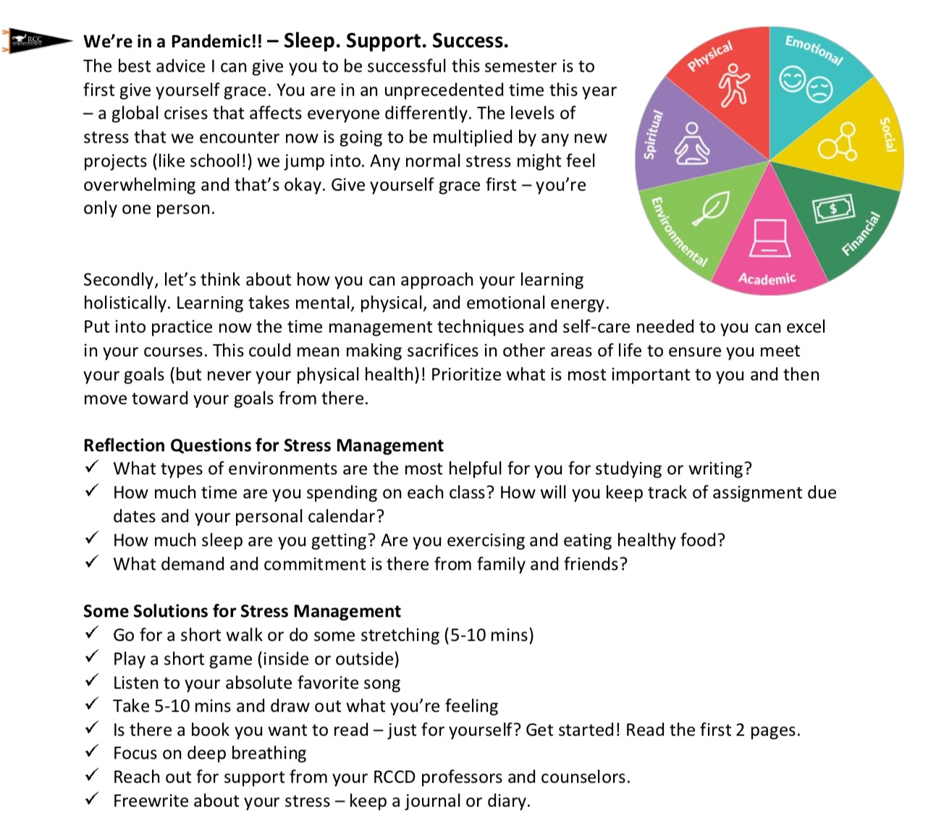

Course Policies
ATTENDANCE & PARTICIPATION
You may not know this now, but you have a lot to contribute to this class. When you miss a class, you not only miss out on content, but you also miss out on fun and engaging activities with your peers and the opportunity to share what you know with us. According to our RCC policy, you are allowed four hours of absence before you may be dropped. I understand that life happens, and when it does, please contact me as soon as possible. [2019 workshop group]
[Remaining material on attendance and participation all excerpted from Wendy Silva]:
Both attendance and active participation in class are important for a productive learning environment; therefore, I expect you to attend each class and participate in the day’s activities. In order to participate well, we must be fully present and prepared for every class; this means you have come to class on time, completed the homework assignments for that day, done all required reading and annotating, brought all necessary course materials with you, including your books, notebooks, writing utensils, etc., and that you are actively participating and present for the entirety of the lesson. By active participation, I mean sharing your ideas during class discussions or group works, staying focused on the activity we are working on, and keeping your phones away, even if you finish something quickly.
- Your voice matters in this class, and I want to make sure everyone gets heard in order for our learning community to create a space for multiple ideas and perspectives. If you are absent, your voice is not being heard, so it is crucial that if you took the time to enroll in classes, pay fees, buy books, etc., you show up to class regularly, on time. We only see each other for a few hours a week, so it is critical that we use our time effectively. I will hold myself to the same standards, showing up for class early, coming to every class prepared, and keeping up with my grading of your assignments in a timely manner.
- Because I know that you are all humans, with busy lives, and a wide variety of responsibilities, you are allowed to miss three classes without question or penalty. Most students like to save these absences for emergencies, in case some unforeseen issue arises.
- Students under extenuating circumstances (severe illness, death in the family, court, etc.) may be excused for absences exceeding three if they communicate with me about their situation and show documentation for their absences.
- After missing three classes, students will be required to have a conference with me to check in. When my students miss a lot of class, I get worried, so I will reach out to you and see what is going on. After missing a full week and a half of classes, students’ grades usually begin to slip, so during our check in we will also discuss your grade and how to make sure you are successful in this class.
- Missing more than three classes will have a negative impact on your participation grade.

Late Policy – TLDR: I accept most late work; always talk to me. [Kelly Douglass]

Essays are due by midnight (11:59pm) on the due date listed. You will submit your papers in the Canvas assignment folder for that assignment. If you cannot make a paper deadline, you can always talk to me 24 hours BEFORE the paper is due, for a free no-penalty extension to a new due date you will set. If you don’t talk to me by midnight the day before it is due, you can ALWAYS turn in your work, but there will be a slight late penalty (5%) to encourage you in the future to talk to me before something is due. As with everything in our class, the most important principle is to talk to me about what you need to succeed.
Reading Unit Quizzes: There are no penalty-free extensions except in the case of emergencies, but you can still do the original quiz or a make-up version for nearly full credit (5% late penalty).
Class participation activities: These activities show your regular weekly participation and contact in class. They can’t be submitted late, though they will be accepted through Sunday of the week assigned. Also, even one activity counts as a passing-level participation, so if you can’t do them all, just try to do one per session.
WRC assignments: These can be submitted late, but like class participation, lab participation should be weekly, so your late WRC work will be accepted for passing but not full credit and your weekly lab attendance will still be absent (no effect on grade).

Plagiarism
Plagiarism is using another person's ideas, processes, results, or words without giving appropriate credit. This includes the copying of language, structure, or ideas of another and attributing (explicitly or implicitly) the work to one's own efforts. Plagiarism means using another's work without giving credit [UCR syllabus template]. The goal of this class is to learn to value your own writing and to give credit to the writing and ideas of others appropriately and fairly. Plagiarism can be unintentional or intentional, but all plagiarism will interfere with this kind of learning and with my ability to assess the quality of your work and help you improve as a writer [2019 workshop group]. So, you can avoid plagiarism by never hesitating to cite sources. Citing your sources establishes your ethos, your credibility as a writer. Writers strive to establish that they have an awareness of the ongoing conversations in the field, and the way we do this, especially as students, is to cite experts within that conversation to validate, support, or illustrate our claims. So I expect you to have citations in your essay unless the assignment specifically states otherwise. Plagiarism is a serious academic offense; it is a violation of both personal and academic integrity. [Tammy Kearn] Plagiarism can result in zero credit for the plagiarized work and an alert to the academic dean of this misconduct to prevent further instances in this or other classes at the college. Ultimately, repeated plagiarism will result in failure in the course and may result in expulsion from the college.

Course Schedule
[Obviously, you will fill in your readings and assignments here, but see below for a possible major assignment schedule that incorporates revision opportunities.]
Date | Topics/Readings/Materials | Due
Week 1
Date – Date
Week 2  Date – Date | Writer’s Inventory / Educational Autobiography
Week 3  Date – Date | Essay 1 – draft for low stakes credit
Week 4
Date – Date
Week 5  Date – Date | Essay 1 – Required Revision / Expansion
Week 6
Date – Date
Week 7  Date – Date | Essay 2
Week 8  Date – Date | Essay 1 Optional Revision
Week 9
Date – Date
Week 10  Date – Date | Essay 3 Formal Research Proposal
Week 11
Date – Date
Week 12  Date – Date | Essay 3 Research Paper
Week 13  Date – Date | Essay 2 Optional Revision
Week 14
Date – Date
Week 15  Date – Date | Essay 3 Required Revision
Finals Week
Date – Date

